4 - WebApi_Handson
Input:
Required code snippet portion –
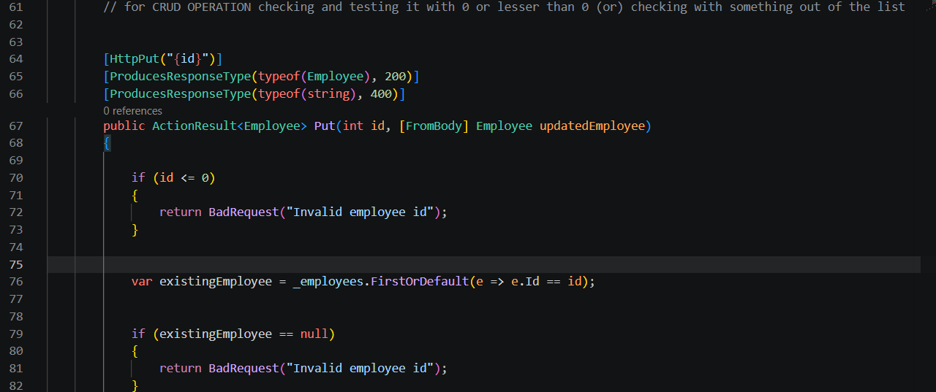
Output:
When id is given ‘0’ –
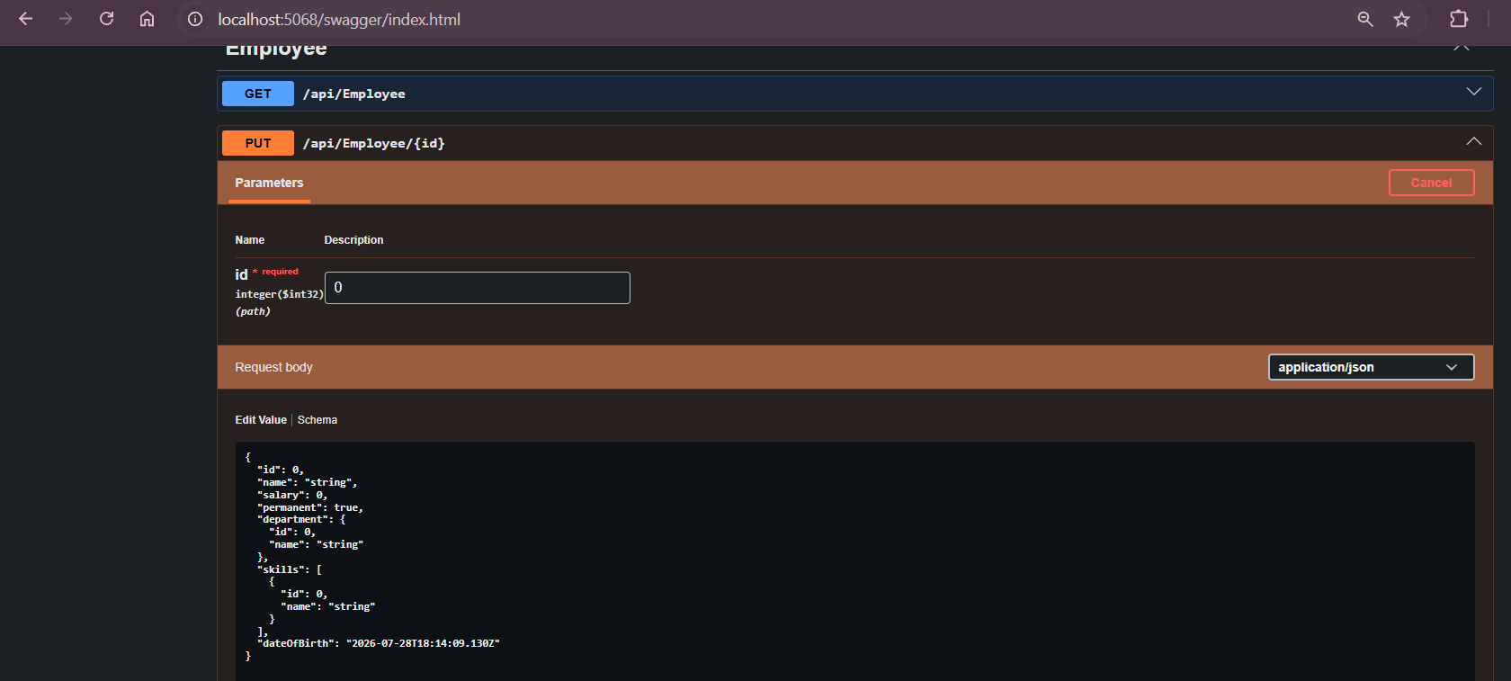
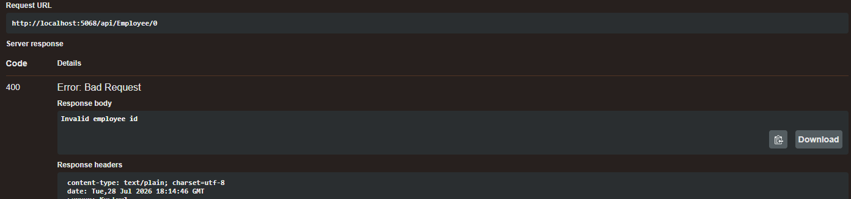

When id is given ‘999’ i.e. out of the list –
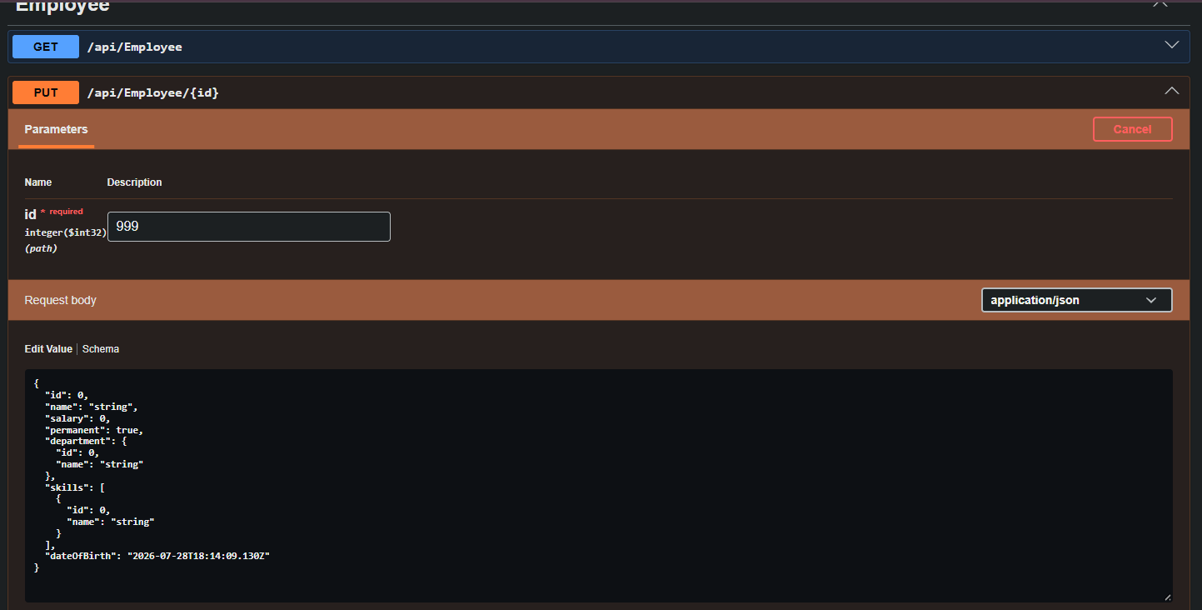
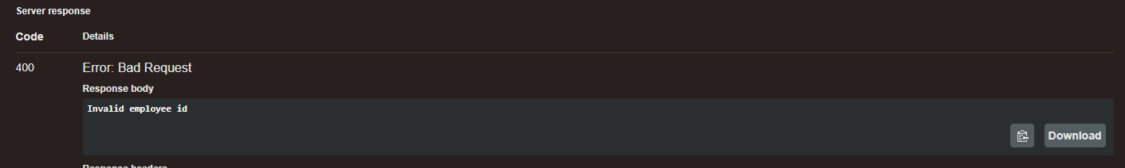
When id is given ‘101’ a valid id then –
